QualityFriend – Test Report
Module 1 + Module 2 · DEV environment · 27 Sep 2026
Date | 27 Sep 2026, approx. 18:10–19:00 (CEST)
Environment | DEV – dev.app.qualityfriend.solutions (production not used)
Test hotel / account | Hotel “Test” · user “Test Tester” (Administrator)
Tested by | Klaus Pichler (Naturhotel Weihrerhof) with Claude
Reference | Mockup “weihrerhof-system 11.html” + developer notes (sections 3–6)
Benchmark | Real operations at Weihrerhof: 23 rooms, seasonal business, German/Italian-speaking team, departments incl. SeaSpa, Kneipp stream & outdoor areas
Structure | Part A – Module 1 (registration, settings, departments/teams, roles, users, 2FA, chat) · Part B – Module 2 (housekeeping, repairs, tasks/checklists, handovers, notes, shift planning, recruiting, manuals, revenue forecast) · Part C – Limits of this test
Numbering | “1-H3” = Module 1, item H3 · “2-H1” = Module 2, item H1 · Figures A1… (Module 1) and B1… (Module 2)

Overview: key issues
As you suggested, Module 1 should be finalised first. The Module 2 findings are documented so they can be planned right away. Some root causes affect both modules (hotel master data, time zone/date, demo data, MCP/knowledge base).
ID | Issue | Priority | Module
1-H1 | Password reset / login with new password does not work | High | 1
1-H2 | No confirmation / invitation emails | High | 1
1-H3 | Open API (REST, webhooks, API keys) missing | High | 1
1-H4 | Integrations show “connected” without credentials, not persisted | High | 1
1-H5 | Knowledge base: error MCP_NOT_ACTIVE (also affects manuals) | High | 1
1-H6 | Demo data + fixed date 19 Aug 2026 on dashboard/header | High | 1
1-H7 | Teams cannot have members assigned | High | 1
1-H8 | No hotel master data in settings | High | 1
2-H1 | Housekeeping room board empty (API returns no rooms) | High | 2
2-H2 | Time zone UTC instead of Europe/Rome | High | 2
2-H3 | Demo content in handovers (AI draft!), shift plan, forecast | High | 2
2-H4 | AI job ad invents benefits; draft cannot be saved | High | 2
2-H5 | Checklists missing from weekly overview; can be completed with open items | High | 2
2-H7 | Recruiting quiz funnel is a static template, not generated | High | 2
2-H6 | Developer command visible in recruiting banner | Medium | 2

Part A – Module 1
Registration, AI API, settings, departments & teams, roles, users, 2FA, chat

1. Summary
The core functions for departments, roles, user editing, trash, activity log, chat and automatic translation work. Before moving on, however, several blockers need to be resolved: password reset and emails, the open API, integrations that only appear to connect, the knowledge base error, hard-coded demo data and a fixed date on the dashboard, and teams without member assignment.
Area | Short finding | Status
1 Hotel registration | Form + validation OK; Italy/hotel fields missing; no confirmation email | Yellow
2 AI API (ChatGPT/Claude) | Keys stored, AI responds; model list outdated, no connection test | Yellow
3 Settings | Hotel master data missing; fake integration connection; knowledge base error | Red
4 Departments & teams | Departments fully working; teams without members/department | Yellow
5 Roles & permissions | Matrix saves; department column fixed/hard-coded, no custom roles | Yellow
6 Users | Editing OK; only 1 department, no language, no invitation email, password reset broken | Red
7 Google Authenticator | QR + key generated; activation to be tested by Klaus on his phone | Yellow
8 User chat | Sending, online status, attachments OK; 1:1 only, empty date separator | Green

Top priorities for the developer
# | Issue | Priority | Source
1-H1 | Password reset does not work; login with the new password fails | High | Klaus
1-H2 | No confirmation email after registration or when a new user is created | High | Klaus
1-H3 | Open API for integrations missing (REST + webhooks + API keys) – for n8n, Brevo, Reguest, ASA | High | Klaus
1-H4 | Integrations: “Connect” shows “connected” without credentials; gone after reload | High | Test
1-H5 | Knowledge base: “Die Anfrage ist fehlgeschlagen” (API 409 MCP_NOT_ACTIVE) | High | Test
1-H6 | Dashboard: demo data in a new hotel + fixed date “Mittwoch, 19. August 2026” in every header | High | Test
1-H7 | Teams: members cannot be assigned anywhere – teams currently have no function | High | Test
1-H8 | Settings: no “hotel master data” section (name, address, logo …) – cannot be changed after registration | High | Test

2. Already reported by Klaus
- Password reset does not work; logging in with the new password is not possible (1-H1).
- No confirmation email for a newly created account (registration) or a new user (1-H2). Requested: double opt-in on registration, invitation email with a “set your own password” link for new staff, sender/templates per language (DE/IT/EN).
- Open API for integrations is missing (1-H3). Needed: documented REST API (e.g. tasks, repairs, handovers, users, housekeeping status), webhooks for events (e.g. “repair created”, “room clean”), API keys per hotel with scopes/expiry, rate limits and logging. Weihrerhof runs its automations via n8n – without an API no connection is possible.

3. Findings by area

3.1 Hotel registration
The form was reviewed and submitted empty (validation). No real account was created because that requires setting a password for a new account – please test submission and the confirmation email yourself.
Works:
- All required fields are validated (“Dieses Feld ist erforderlich.”); terms checkbox is mandatory.
- Language switch DE/IT/EN on the page.
Remove / change:
- “Ansprechperson” (contact person) duplicates first/last name → remove, or clearly label it e.g. “Accounting contact”.
- Placeholders “QualityFriend GmbH” and “Hotel Weihrerhof” → neutral examples (“e.g. Sample Ltd.”, “e.g. Hotel Alpenblick”).
- “Country” as free text → dropdown (then province/region depending on country).
- Mark required fields with *; “Terms of use” and “Privacy policy” are not linked.
Missing (important for hotels in Italy / South Tyrol):
- Tax code / Codice Fiscale, PEC address and SDI recipient code (Italian e-invoicing), legal form.
- Province (e.g. BZ), time zone, default hotel language.
- Hotel profile: number of rooms, star rating, business type (seasonal with opening periods/closures), default check-in/check-out time (dashboard currently shows a fixed “Check-in from 15:00”), website.
- PMS in use (e.g. ASA, others) – important for later integration.
- Separate email for invoices and for login; password strength indicator.
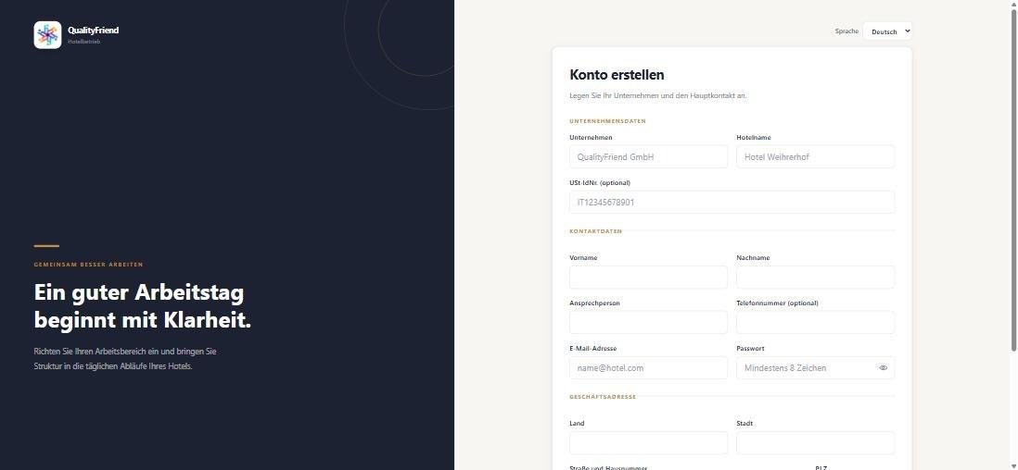
Fig. A1 – Registration: company and contact details
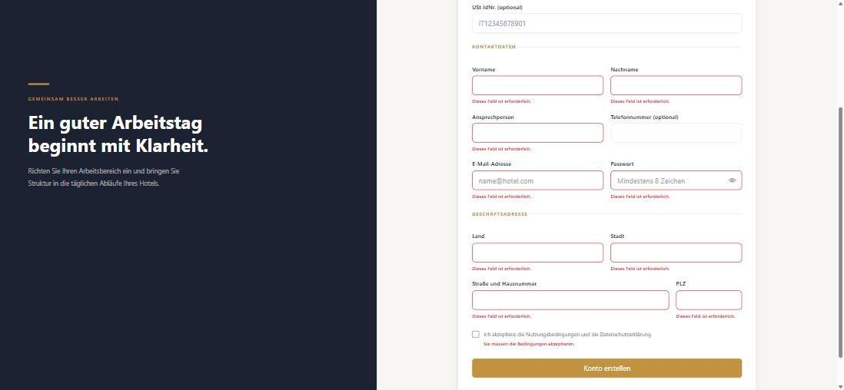
Fig. A2 – Validation on empty submit works

3.2 ChatGPT / AI API key
Works: ChatGPT and Claude keys are stored and masked (“Gesetzt ••••”). Active provider: ChatGPT · gpt-4o-mini. The AI assistant responds, so the key works.
Issues / requests:
- The model list is fixed and outdated (gpt-4o-mini, gpt-4o, gpt-4.1-mini, gpt-4.1 / claude-sonnet-4-5, claude-haiku-4-5, claude-opus-4-5). Better: fetch available models from the provider or allow free text.
- No “Test connection” button and no display of monthly usage/cost.
- The text on the Integrations page mentions AI providers “Perplexity, DeepSeek” – these do not exist in the AI settings.
- In the test hotel the AI assistant shows “Connected to your operational data · Weihrerhof” (hotel name hard-coded) and does not know the created departments (“cannot see the information …”) – probably because MCP is not active.
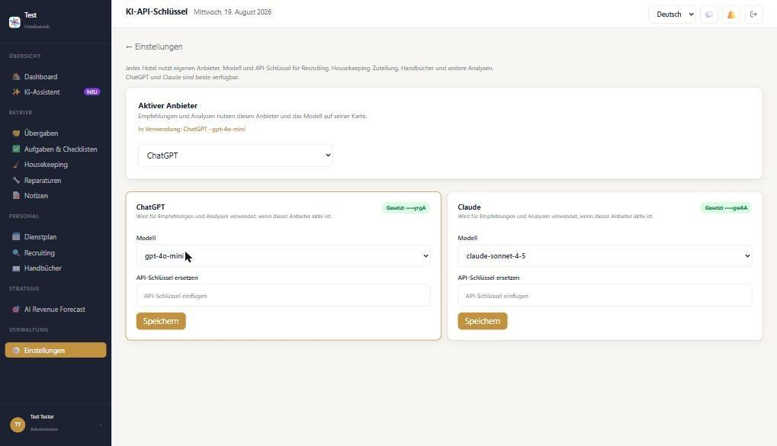
Fig. A3 – AI API keys: provider, model, key
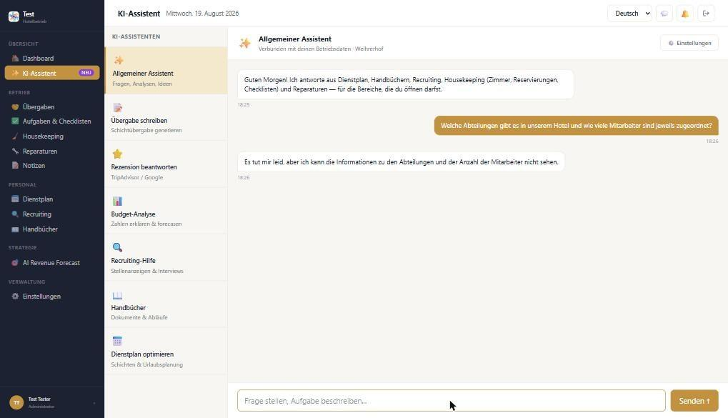
Fig. A4 – AI responds but does not know the departments; “Weihrerhof” hard-coded in the test hotel

3.3 Settings
The overview largely matches the mockup (Users & teams, AI & knowledge base, General) and adds AI API, Google Authenticator, Integrations/API and MCP.
Works: saving the default language (EN/DE/IT); trash incl. restore; activity log with filters by date and user; switching the UI between DE and IT.
Bugs:
- Integrations (1-H4): Clicking “Connect” for Brevo immediately shows “Brevo wurde verbunden” – without an API key or login. After reloading, Brevo is “not connected” again. ASA PMS is shown in the test hotel as “connected … already live” – probably hard-coded. “Disconnect” and a connection status/test are also missing.
- Knowledge base (1-H5): Opening it shows “Die Anfrage ist fehlgeschlagen.” (GET /api/settings/knowledge/vector-stores → 409 “MCP_NOT_ACTIVE”). If the knowledge base requires MCP, please show a clear message with a link to activate MCP.
- Dashboard/header (1-H6): Every page shows “Mittwoch, 19. August 2026” (today is 27 Sep 2026 – the trash shows the correct date). The greeting is “Guten Morgen” even in the evening. In an empty test hotel the dashboard shows demo content from the mockup (AI daily analysis with rooms 45 & 51, Zorah, TripAdvisor; activity list; rating 4.9 with 137 reviews).
- The weather widget is empty (“–”), and the text “Weather is updated twice a day …” appears twice. According to the text the hotel address is used – but it cannot be maintained anywhere after registration.
- Language and roles save without feedback (no “Saved” message).
Missing in settings (from Weihrerhof’s perspective):
- Hotel master data (1-H8): name, address, logo, contact, number of rooms, season/closures, check-in/check-out times, time zone.
- Security: 2FA required per role, password rules, automatic logout, admin reset of 2FA/password for staff.
- Email & notifications: sender, templates (invitation, password reset) in DE/IT/EN, push/email per event.
- Translation glossary: terms that must not be translated (e.g. Housekeeping, SeaSpa, Kneippbach) or fixed translations.
- Privacy/GDPR: data export, retention periods (also for the trash), data processing agreement.
- Subscription/billing (plan, invoices).
- Activity log: as in the mockup, add a filter by type (checklists, handovers, repairs) and an export (PDF/CSV) as evidence for insurers and authorities. Some texts are technical (“role_permission … MANAGEMENT · recruiting: false”), and the user change entry reads “test01@gmail.com to test01@gmail.com” instead of the actual change (department).
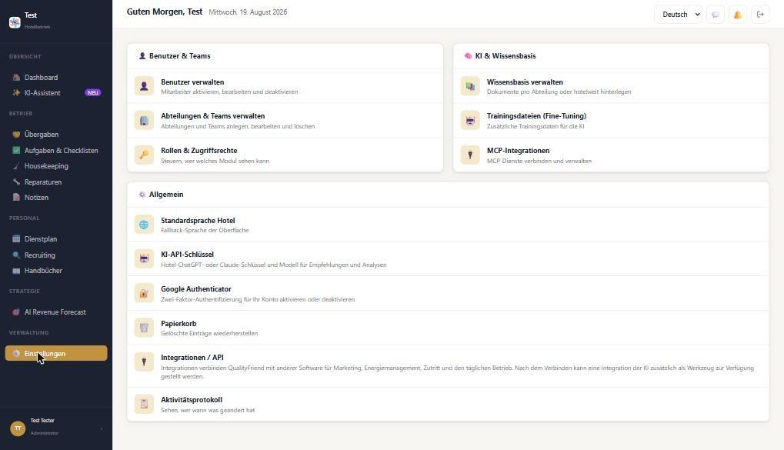
Fig. A5 – Settings overview
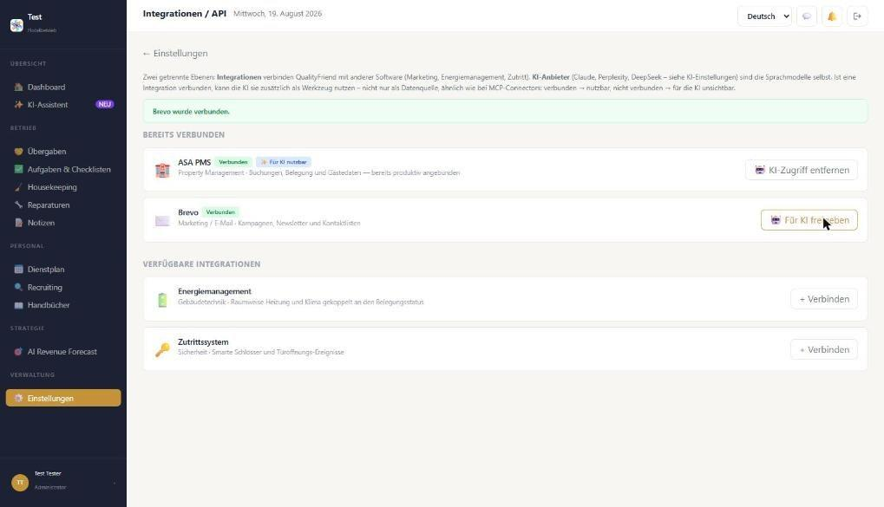
Fig. A6 – Brevo “connected” without credentials …
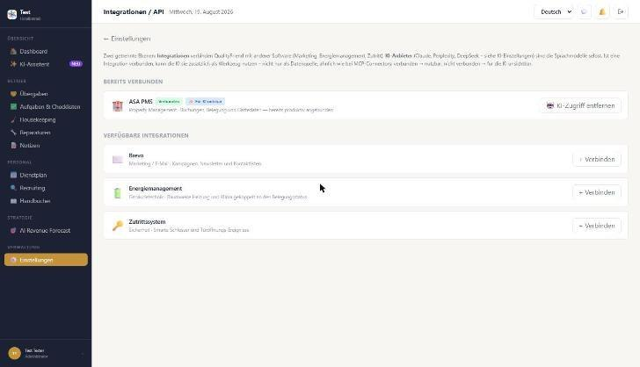
Fig. A7 – … not connected again after reload
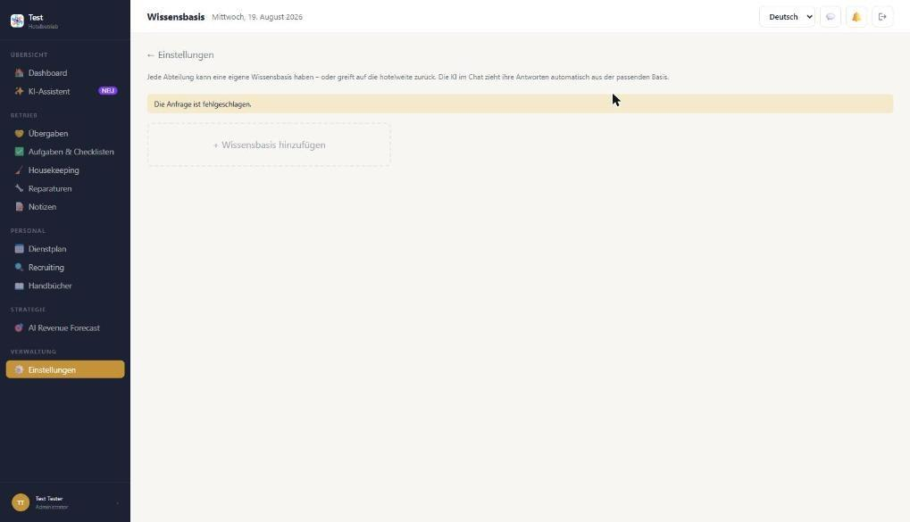
Fig. A8 – Knowledge base: “Die Anfrage ist fehlgeschlagen”
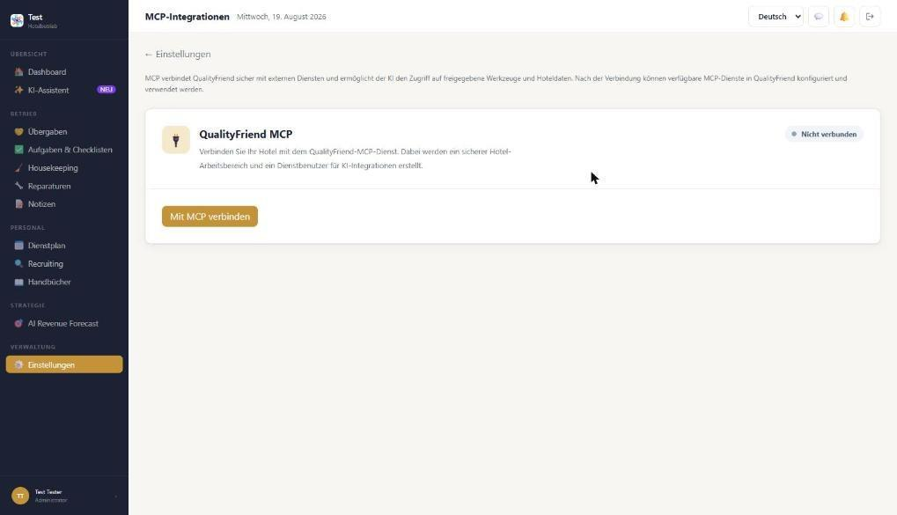
Fig. A9 – MCP not connected (per developer approx. 50% remaining)
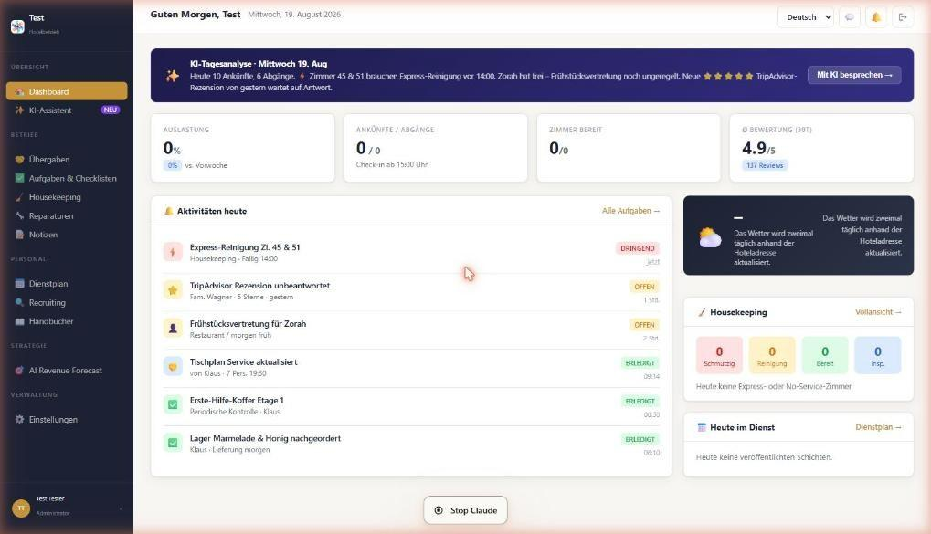
Fig. A10 – Dashboard in the empty test hotel: demo data, fixed date, weather empty/duplicated
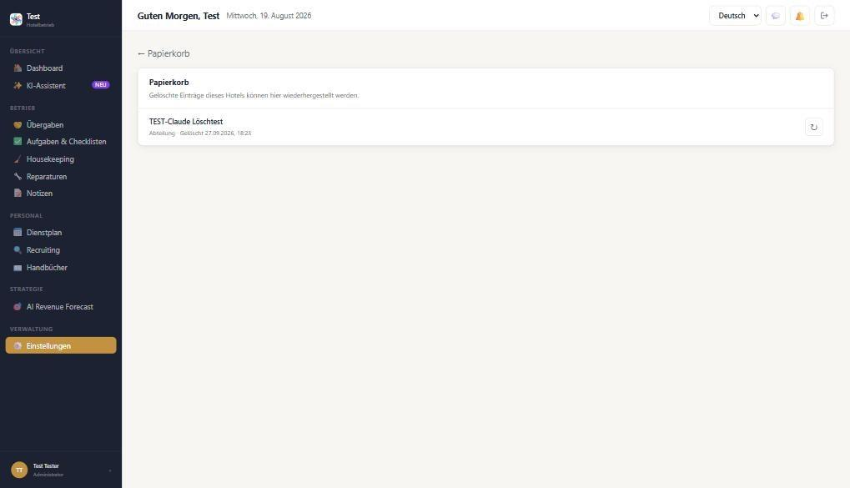
Fig. A11 – Trash with restore (works)
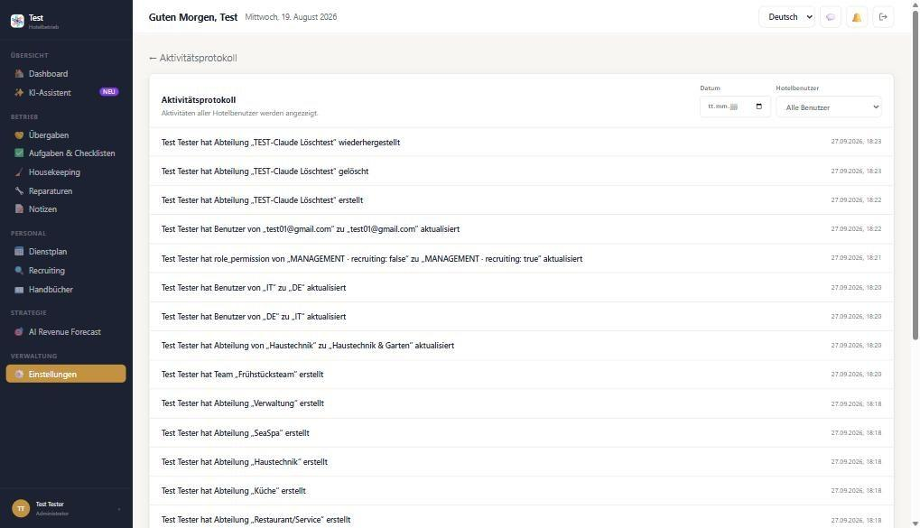
Fig. A12 – Activity log records all test steps

3.4 Departments and teams
Created the Weihrerhof departments: Rezeption, Housekeeping, Restaurant/Service, Küche, Haustechnik (→ renamed “Haustechnik & Garten”), SeaSpa, Verwaltung and the team Frühstücksteam.
Works:
- Create, rename, delete → trash → restore.
- Validation: empty name and duplicate name (“Dieser Name existiert bereits.”).
- Automatic translation, also after renaming: “Haustechnik & Garten” → “Manutenzione & Giardino”, “Frühstücksteam” → “Team Colazione”.
- Staff counter updates (Verwaltung: 1 employee after assignment).
Bugs / requests:
- Teams (1-H7): The team dialog only has “Name”. There is no assignment of members, department or team lead – not in the user form either. All teams stay at “0 members”.
- Translations can be neither viewed nor corrected. Example: “Housekeeping” became “Servizio di pulizia” – in South Tyrolean hotels the Italian-speaking staff also say “Housekeeping”.
- Deleting happens without a confirmation prompt. The trash catches it, but a confirmation or an “Undo” message is preferred. (Unconfirmed: one delete click did not respond – possibly caused by the test tool.)
- The order of departments changes after reload → sort alphabetically or allow drag & drop.
- The message “Dieser Name existiert bereits” stays at the top of the page after “Cancel”.
- Wording: dialog titles “Hinzufügen Abteilungen” / “Bearbeiten Teams” → “Abteilung hinzufügen” / “Team bearbeiten”. The back link reads “← Abteilungen verwalten” (trash/log also show their own name) → “← Einstellungen”. The header shows “Guten Morgen, Test” instead of the page title.
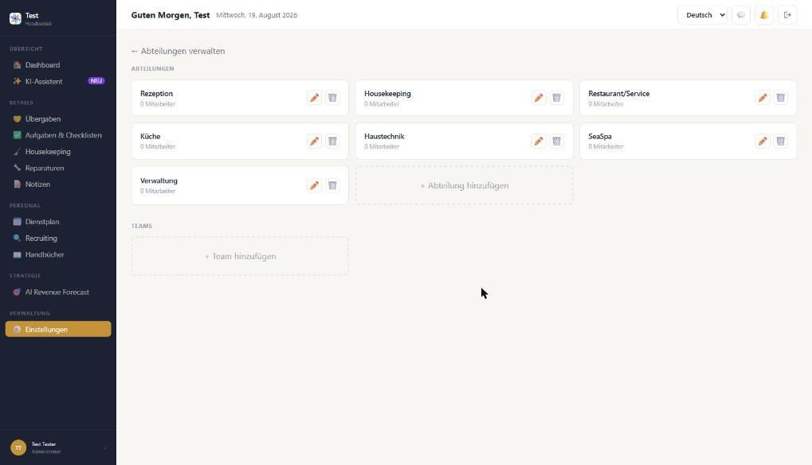
Fig. A13 – Weihrerhof departments created
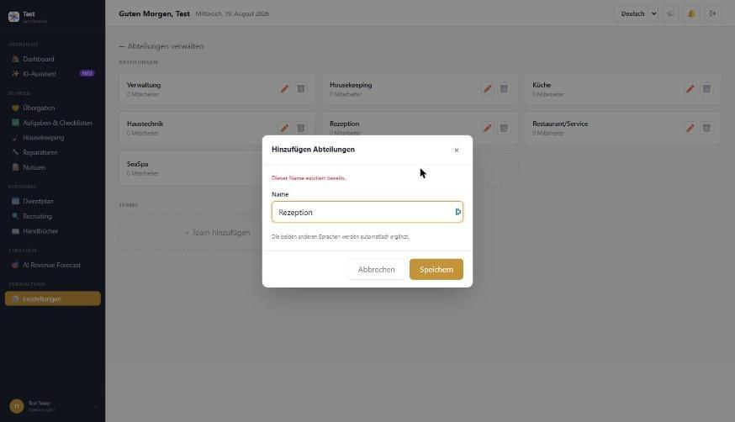
Fig. A14 – Duplicate check works
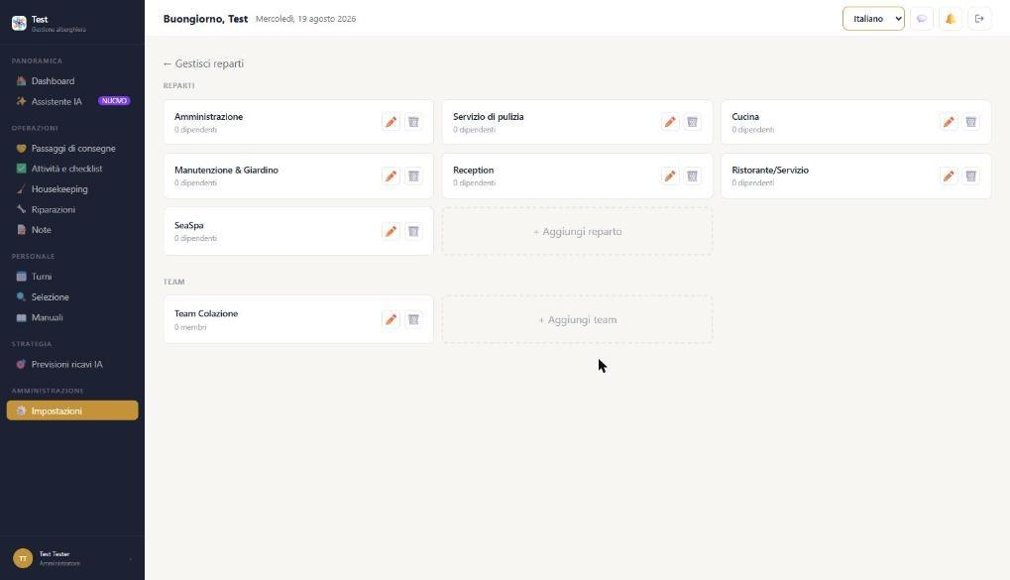
Fig. A15 – Automatic translation into Italian
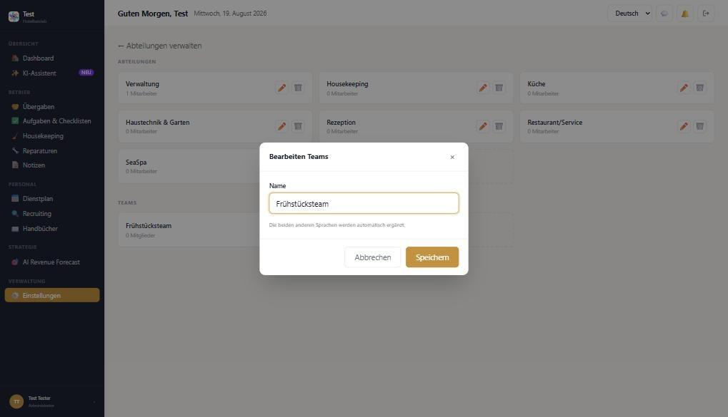
Fig. A16 – Edit team: name only, no members

3.5 Roles and permissions
Works: The matrix of 4 roles × 17 modules saves automatically and persists after reload (tested: Recruiting enabled for “Management”). Administrator always has all permissions.
Bugs / requests:
- The “Departments” column is not editable and hard-coded: it shows “Housekeeping, Haustechnik” although the department was renamed to “Haustechnik & Garten”. It should use the hotel’s actual departments and be selectable.
- Custom roles cannot be created (e.g. “Night reception”, “SeaSpa lead”, “Seasonal/temporary staff” with restricted rights).
- Repairs are only enabled for Housekeeping and Haustechnik. At Weihrerhof every department must be able to report damage (in the mockup via “⚡ Melden” in the header) – please separate “report” from “manage”.
- Handovers are only intended for Rezeption and Restaurant/Service – Küche, Housekeeping and SeaSpa also need handovers.
- The individual settings areas (AI API, integrations, trash, log, 2FA enforcement) are missing from the matrix – please make them controllable separately.
- Permissions are only “view yes/no”. Preferred: view / create / edit / delete.
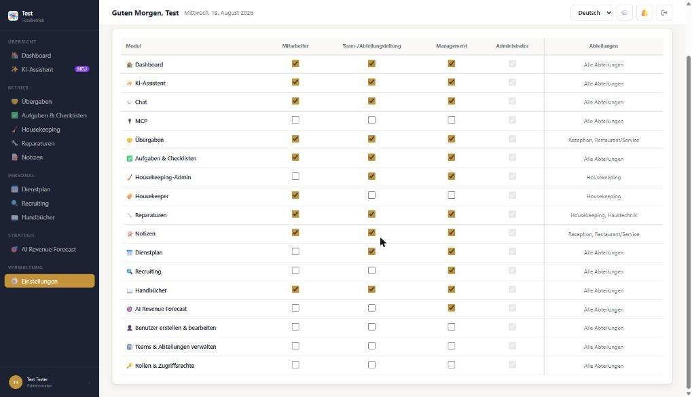
Fig. A17 – Role matrix (department column fixed)

3.6 Users
Editing was tested on the “Test Tester” account (department → Verwaltung). Please create a new user yourself: the form requires the admin to set a password, which I cannot enter on your behalf.
Works: list with search; edit and save (department is applied and counted in departments); status active/inactive; own account cannot be deleted.
Bugs / requests:
- Only one department per person. Many Weihrerhof staff work across departments (e.g. reception + service) → multiple assignment with a primary department.
- No field for the employee’s language (DE/IT/EN) – important for emails, translations and the default view.
- No team assignment (see 1-H7).
- The admin sets or changes the password directly → better an invitation email in which the employee sets their own password (related to 1-H1/1-H2).
- The role of one’s own account can be changed → add a safeguard so the last administrator cannot demote themselves.
- The mockup notes that new staff are created via Recruiting – please clarify whether both ways are intended.
- Useful for seasonal operation: start and end dates and automatic deactivation at the end of the season.
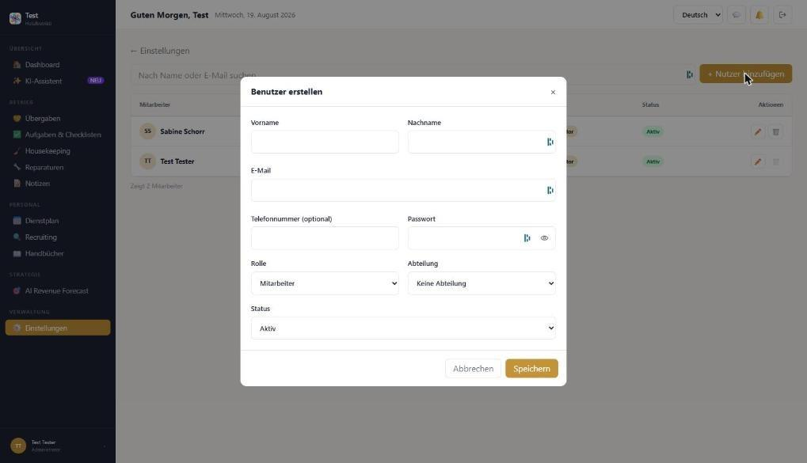
Fig. A18 – Create user: one department, no language, admin sets password
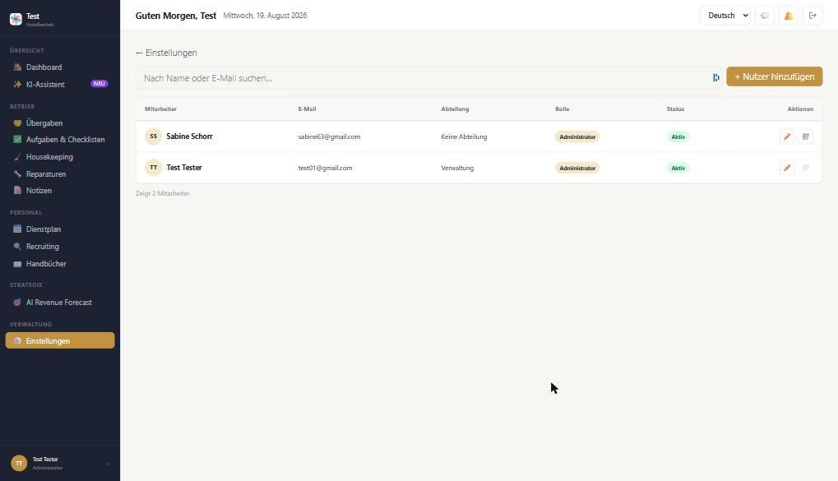
Fig. A19 – Edit saved (department Verwaltung)

3.7 Google Authenticator (2FA)
Works: status “disabled” is shown; “Set up authenticator” generates QR code, manual key and the 6-digit code field. (QR/key blurred in the screenshot.)
Still to test (by Klaus on his phone): enter code → activate → log out → log in with 2FA → deactivate. I did not activate 2FA because it requires a code from the phone.
Requests:
- “Cancel” button during setup.
- Backup/recovery codes on activation.
- Admin can reset an employee’s 2FA (phone lost/replaced).
- 2FA mandatory per role (e.g. Administrator and Management).
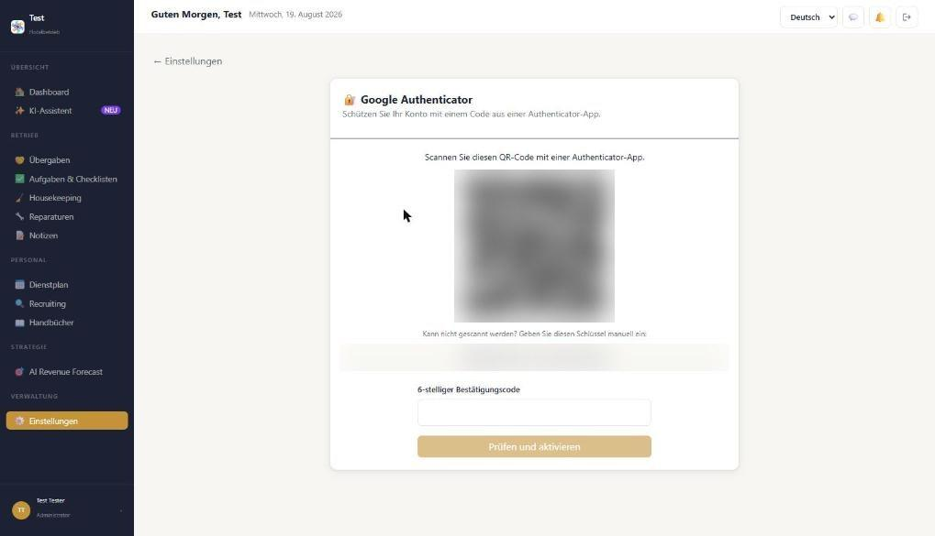
Fig. A20 – 2FA setup (QR and key blurred)

3.8 User chat
A test message was sent to “Sabine Schorr” (“Chat-Test … bitte ignorieren”).
Works: chat icon in the header, people search, online status, send with Enter, preview in the list, attachments (document, photo & video, voice message) and microphone.
Still to test: receiving on the other side (second login), notification/bell, uploading attachments, voice message, DE ↔ IT translation in chat.
Requests / bugs:
- The date separator above the message only shows “…” instead of “Today” or the date.
- 1:1 chat only → group or department chats (e.g. “Housekeeping”, “Küche”) are important for shift communication at Weihrerhof.
- Read receipts and automatic translation of messages (Italian- and German-speaking staff).
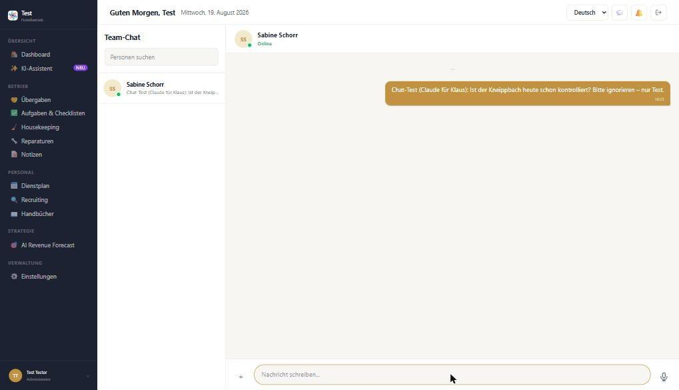
Fig. A21 – Chat: message sent, empty date separator

4. Test data created in DEV (Module 1)
- Departments: Rezeption, Housekeeping, Restaurant/Service, Küche, Haustechnik & Garten, SeaSpa, Verwaltung.
- Team: Frühstücksteam.
- Test Tester → department Verwaltung; role Management → Recruiting enabled.
- Department “TEST-Claude Löschtest” (in the trash); chat test message to Sabine Schorr.
- Brevo “connected” for testing (not persisted); 2FA setup opened but not activated.

Part B – Module 2
Housekeeping, repairs, tasks & checklists, handovers, notes, shift planning, recruiting, manuals, AI revenue forecast
Preparation: housekeeping set up by Klaus: floors 1 + 2, rooms 45 (Mitterstieler) and 56 (Windspiel), extra tasks “Fenster Parterre”, “Radkeller”, “Bootshaus”. Note: the test hotel has only 2 users, so role views, assignments to cleaners and the housekeeper view could only be checked to a limited extent.

1. Summary
Repairs, tasks, notes, shifts and absences can be created, edited and completed. Automatic translation and AI prioritisation of tasks work. Critical: the housekeeping room board shows no rooms. The time zone is set to UTC. Several modules still show hard-coded demo content – including the AI handover draft, which writes invented guest data into a real handover. The AI job ad invents benefits.
Module | Short finding | Status
Housekeeping | Settings OK; room board empty (API returns no rooms) | Red
Repairs | Create, status, comment OK; no urgency/category | Yellow
Tasks | Create, AI priority, complete OK; no time/priority field | Green
Checklists | Template + recurring checklist OK; weekly overview does not count it | Yellow
Handovers | Saving OK; AI summary/draft = demo text | Red
Notes | Create with visibility per department OK | Green
Shift planning | Shift + vacation OK; break not deducted, demo notices | Yellow
Recruiting | AI text OK but invented benefits; draft cannot be saved; quiz funnel is a static template | Red
Manuals | Form OK; upload depends on knowledge base (MCP) | Yellow
AI revenue forecast | Entirely demo data (per developer still open) | Yellow

Top priorities for the developer
# | Issue | Priority
2-H1 | Housekeeping room board empty: rooms 45 and 56 exist and are assigned to floors, but GET /api/housekeeping/rooms?board=1 returns “rooms: []”. If rooms are meant to appear only via PMS import, manually created rooms must still be visible (testing / fallback if the PMS is down). | High
2-H2 | Time zone UTC instead of Europe/Rome: the board API reports “timeZone: UTC” and the checklist shows “completed 16:45” instead of 18:45. This affects day change, due times and the housekeeping reset. | High
2-H3 | Demo content in a real hotel: AI summary of handovers, “Neue Übergabe mit KI ausfüllen” (fills in invented rooms/guests/staff!), shift plan notices (Zorah, 24 Aug, “1 on vacation”) and AI revenue forecast. | High
2-H4 | AI job ad invents benefits (free meals, flexible hours), ignores input (lakeside location, accommodation, start April 2027 → “immediately”) and changes the title. A draft cannot be saved without images (no error message). | High
2-H5 | Checklists: a completed weekly checklist appears neither under “Periodic checks (this week)” nor under “Completed this week”. Completion is possible with an open item without warning, and the completion comment is not shown. | High
2-H7 | Recruiting quiz funnel is not generated: “Kurzes Quiz” always loads a hard-coded template from a craft/carpentry business (“Kunden mit Holzkunst begeistern”, “Muster GmbH”), placeholders ([Berufsbezeichnung], [Stadt], “XX € / Stunde”) are not replaced, job data from the classic form is not carried over, and there is no “Generate with AI” action. | High
2-H6 | Developer command visible in recruiting: “Nach dem Deploy: docker compose exec app npm run ai_recomendation:daily”. | Medium

2. Findings by module

2.1 Housekeeping
Works: settings for floors, room categories (with cleaning times), rooms (with room checks and arrival checks) and extra tasks; report per working day; KPIs “Rooms total 2 / 2 floors”.
Bugs / requests:
- 2-H1: The room board only shows the floor numbers “1” and “2” without rooms. Setting status, assigning and express cannot be tested.
- Daily plans: no cleaner appears because no user belongs to the Housekeeping department. A hint is missing (“Please assign staff to the Housekeeping department”). “KI-Vorschlag verteilen” (AI distribution) gives no feedback.
- If the room name is empty, the list shows “RN_45” → better just “45” or “Room 45”.
- Rooms, categories and extra tasks cannot be deleted – only edited.
- The legend “← 78 Aus Zimmer · → 78 In Zimmer” is unclear (placeholder “78”?).
- The “Bericht” (report) tab disappears while in housekeeping settings.
- Weihrerhof request: outdoor areas as “rooms” or extra tasks with a rhythm (boathouse weekly, bike cellar daily in season).
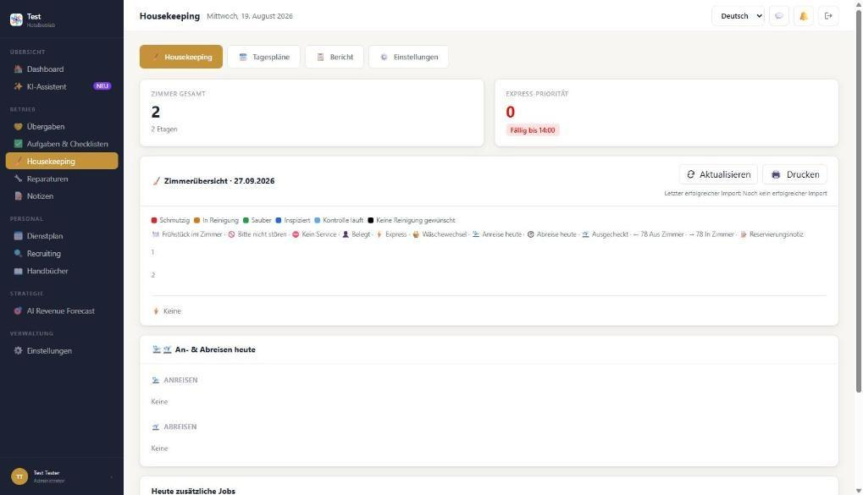
Fig. B1 – Room board: floors 1 and 2 without rooms
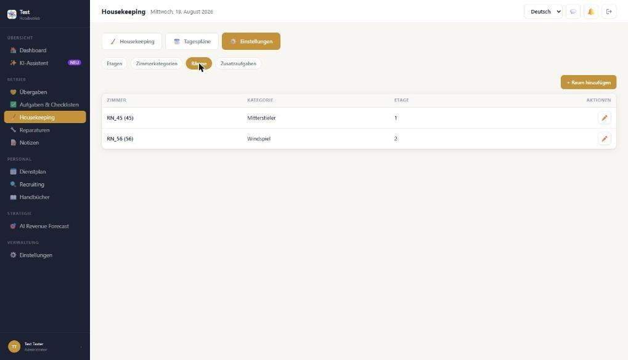
Fig. B2 – Rooms 45 and 56 exist
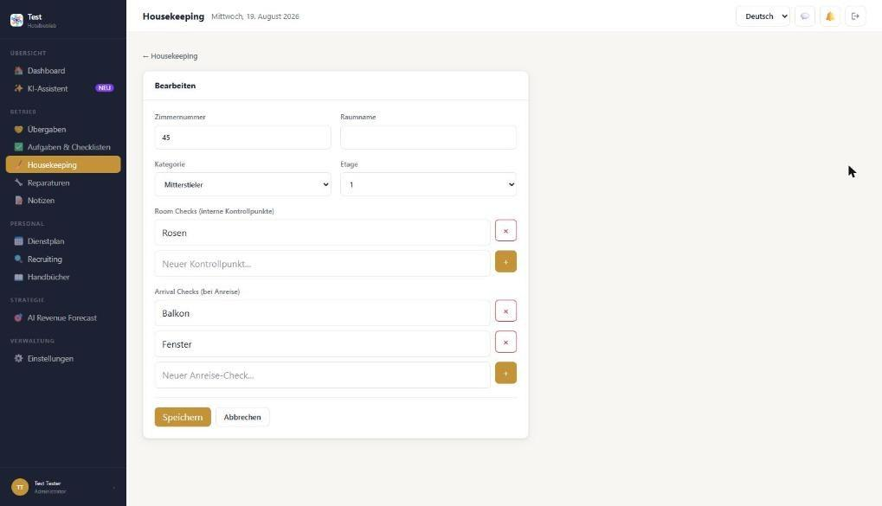
Fig. B3 – Edit room with room checks and arrival checks (works)
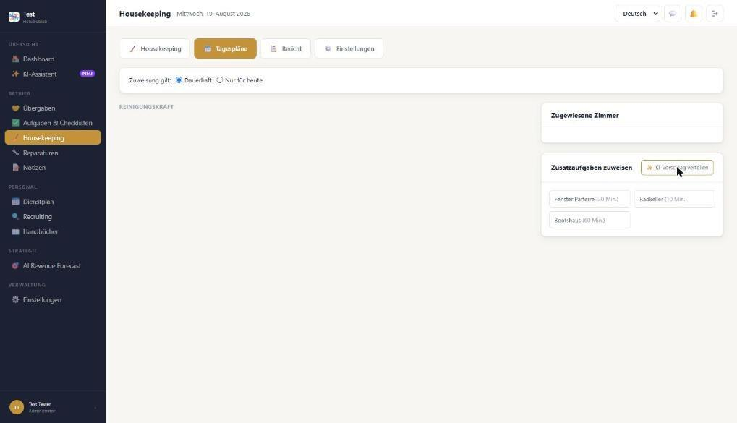
Fig. B4 – Daily plans: no cleaner, no hint

2.2 Repairs
Test case: “Kneippbach-Pumpe verstopft (Sediment)” (Kneipp stream pump clogged), location garden/outdoor, assigned to Test Tester, tag “Pumpe” → status “In progress” → comment “spare part requested from Messner”.
Works: creation incl. translation notice and toast; status workflow New → Accepted → In progress → Waiting (spare part/external) → Done; comments; list with filters; statistics per location; counter in the sidebar.
Bugs / requests:
- No urgency field (low/normal/high/urgent) and no category (electrical, plumbing/heating, furniture, IT). Both are in the mockup.
- Locations are partly fixed (Flur Etage 2, Heizraum, Keller …). It is unclear where they are maintained. For Weihrerhof e.g. indoor pool, Kneipp stream, boathouse, lakeshore/jetty and bike cellar are missing → maintainable location list.
- “Ø response time” shows “0T” → show hours/minutes. “Open 1” and “In progress 1” count the same repair twice.
- A repair assigned to me does not appear under “My tasks / AI priorities for today”. According to the mockup, tasks, repairs, checklists and handovers belong together.
- The quick report “⚡ Melden” from the mockup (photo, voice, AI detects category) is missing.
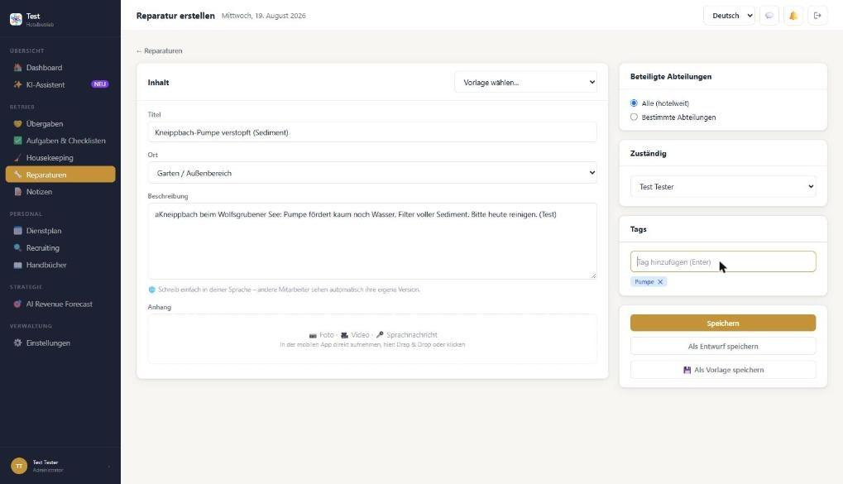
Fig. B5 – Create repair: no urgency/category
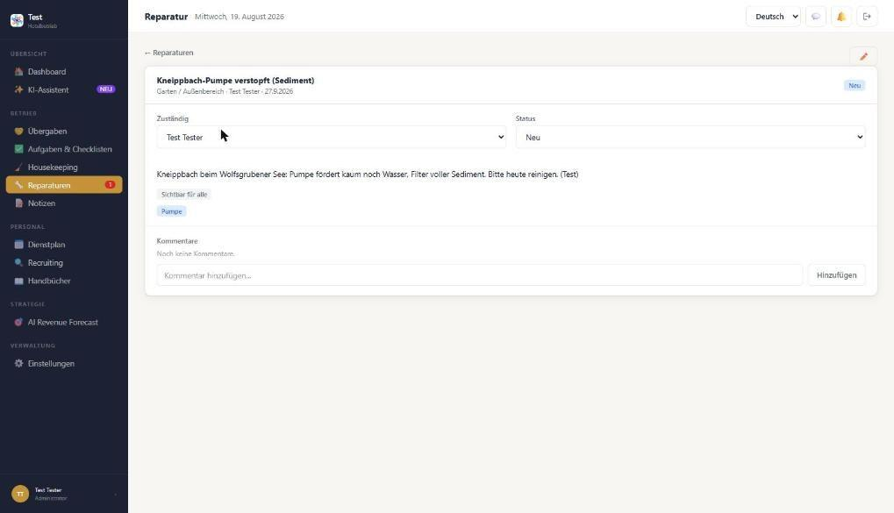
Fig. B6 – Detail with status and comment
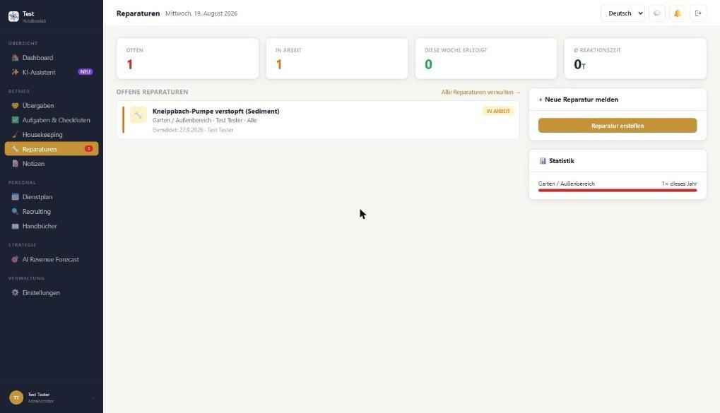
Fig. B7 – Overview: “Ø response time 0T”, double count

2.3 Tasks & checklists
Test cases: task “Willkommenspaket Zimmer 45 vorbereiten (Hochzeitstag)” (welcome package, anniversary), due today, person Test Tester → done. Checklist “Wochenkontrolle Hallenbad & Kneippbach” (weekly check indoor pool & Kneipp stream, 3 items, department Haustechnik & Garten, weekly on Mondays) → saved as template → created from template → completed with 2 of 3 items.
Works: create and tick off tasks; AI prioritisation rates the task as “HIGH”; weekly progress per person; save and load templates; recurrence (rhythm, weekdays, start, end date); “Recent completions” with name.
Bugs / requests:
- 2-H5 (see above). In addition, the checklist can be completed before its start date (28 Sep). Status “Done” on a recurring checklist – when does the next occurrence appear?
- Completion time is shown in UTC (16:45 instead of 18:45) → 2-H2.
- No default templates. The mockup includes: periodic safety check, goods receipt, room inspection, seasonal deep clean, Christmas preparation.
- Checklist items are checkboxes only. The indoor pool needs measurements (pH, chlorine, temperature) and photo evidence. A failed item should create a repair directly.
- Tasks: no time field (e.g. “by 15:00”), no manual priority, no attachment, no room reference.
- Saving as template shows “Checkliste gespeichert” → should say “Template saved”. (Unconfirmed: the first click on the template did not respond – possibly caused by the test tool.)
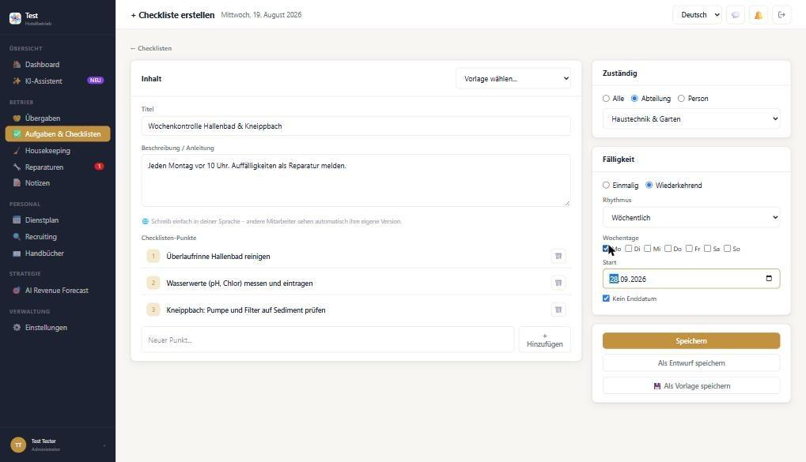
Fig. B8 – Checklist indoor pool & Kneipp stream, weekly on Mondays
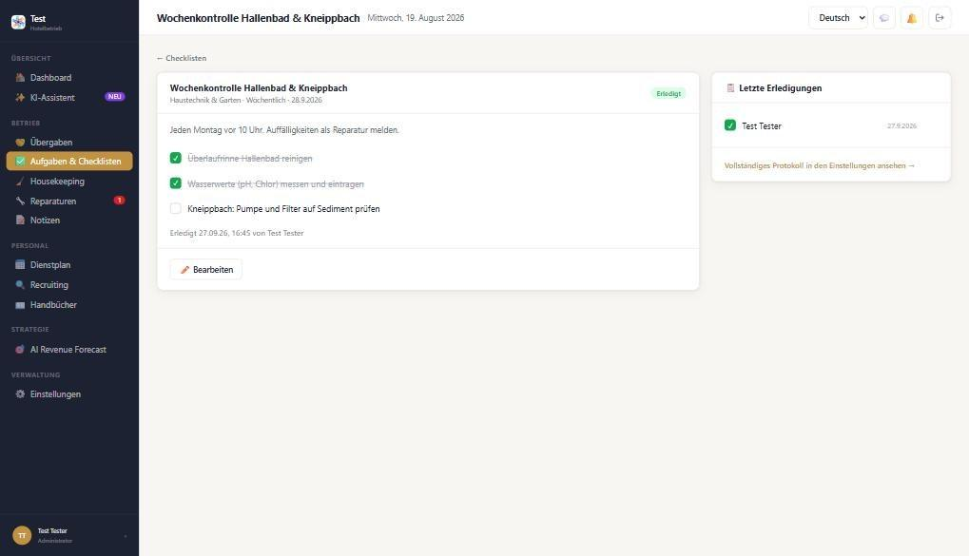
Fig. B9 – Completed despite open item; time in UTC
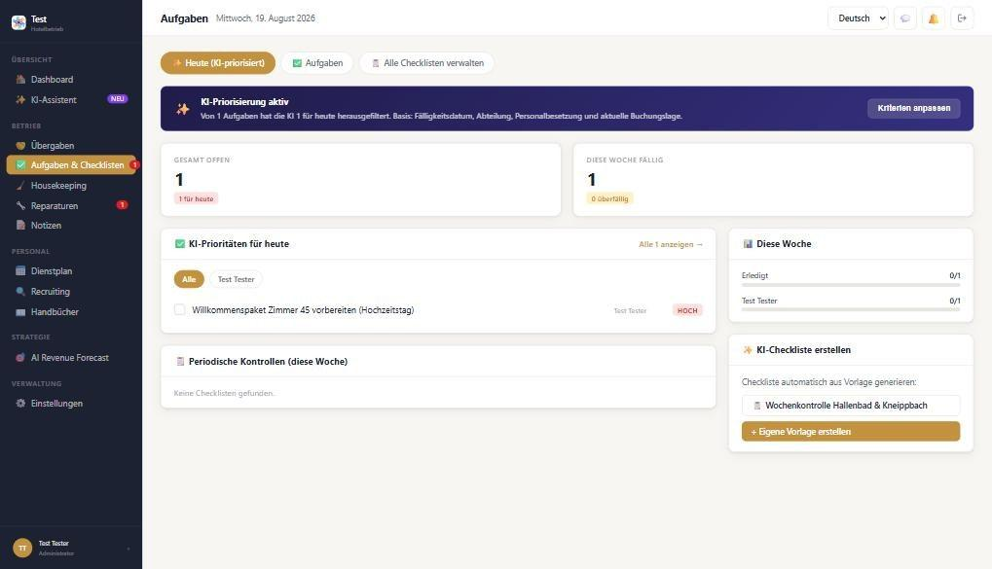
Fig. B10 – AI prioritisation recognises the task (works); checklist missing under “Periodic checks”

2.4 Handovers
Test case: “Frühschicht → Spätschicht Rezeption” (early → late shift reception) with room 45 (anniversary), room 56 (rowing boat at 9:00) and note “Kneipp stream pump out of order”.
Works: saving with visibility (hotel-wide, departments, only me), tags, draft and template; translation; history.
Bugs / requests:
- 2-H3: The “AI summary” always shows the mockup text (10 arrivals, room 48, Zorah …) instead of the real handover. “Neue Übergabe mit KI ausfüllen” writes the same invented text into the form as an “AI draft”. If saved, the handover contains false information.
- The handover is free text only. The mockup includes: shift from → to, handed over by → taken over by, time/due, sections (urgent, special guests, stock & other) and confirmation “read/taken over” by the next shift.
- “Current handovers” only shows pinned handovers – a new open handover should appear there automatically.
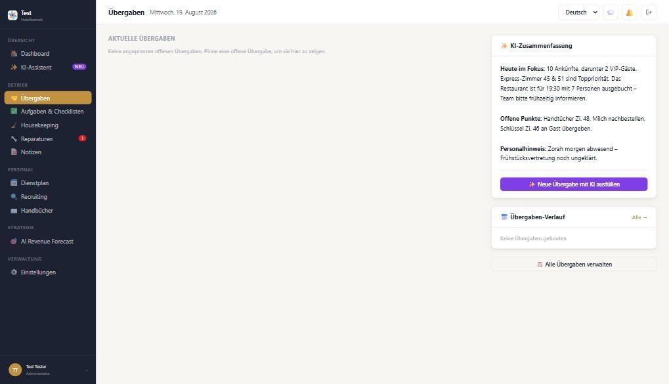
Fig. B11 – AI summary with demo text; real handover only in history
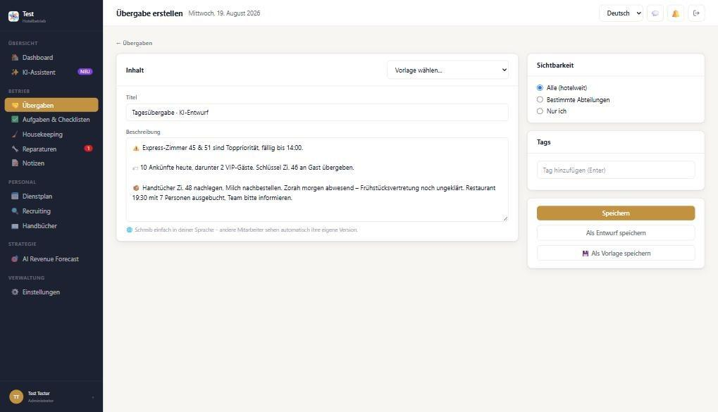
Fig. B12 – “Fill with AI” produces invented content (not saved)

2.5 Notes
Test case: “Stammgäste Fam. Huber – Zimmerwunsch” (regular guests’ room request: room 56 with lake view, rental bikes), visible to reception only.
Works: create, visibility (hotel-wide / departments / specific user / only me, incl. notice that AI does not use private notes), comments, “mark as inactive”.
Requests: link to room or guest (regular guest knowledge), expiry date/reminder. Attachment upload could not be tested.
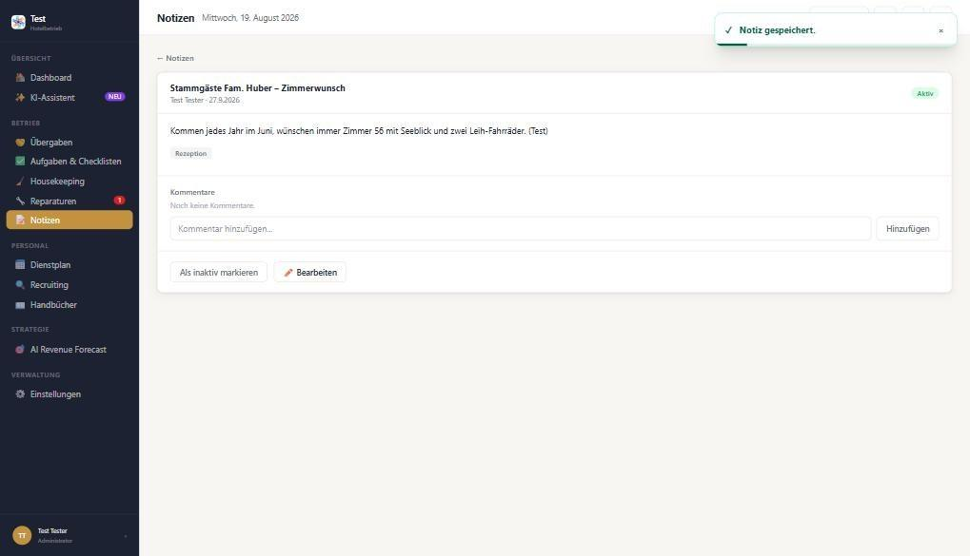
Fig. B13 – Note saved (works)

2.6 Shift planning
Test cases: shift Test Tester, Mon 21 Sep, 09:00–17:00 with 30 min break; vacation 5–9 Oct 2026.
Works: weekly plan, create shift (manual, break, note, repeat), “publish changes”, export/print buttons, statistics per department, absence created and automatically approved.
Bugs / requests:
- 2-H3: “1 on vacation”, “Open shifts 1 – breakfast Mon” and the yellow notice “Monday 24.8 breakfast unstaffed – Zorah …” are demo content. There was no absence entry at that time.
- Planned hours and statistics show 8 h instead of 7.5 h – the break is not deducted.
- Overtime cannot be calculated because no target/contract hours are stored per employee.
- Absence types: only “Freistellung” (leave) and “Urlaub” (vacation); sickness is hidden as “paid sick” under leave. For South Tyrol/Italy separate types are needed: ferie, permessi/ROL, malattia, rest day, vocational school (apprentices), maternity. Plus a remaining-vacation balance.
- The list shows the date as “2026-10-05” → 05.10.2026. The number of days is missing. The toast says “Freistellung gespeichert” although it was vacation. No edit/delete action.
- Not tested: shift templates, shift swap, “My plan”, AI suggestion (requires several employees).
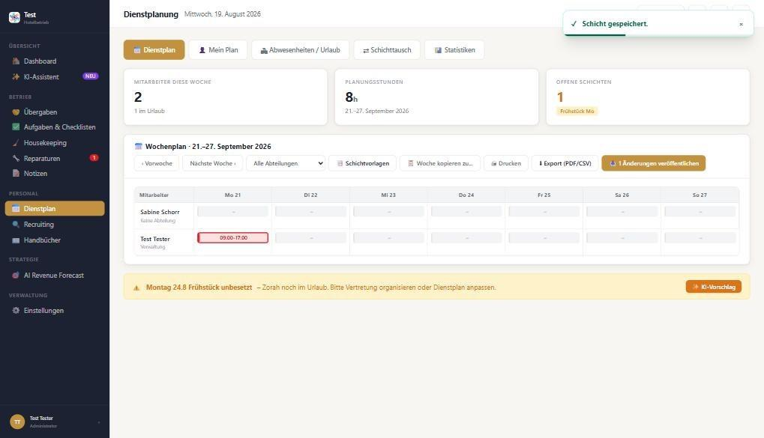
Fig. B14 – Shift saved; 8 h instead of 7.5 h; demo notice Zorah
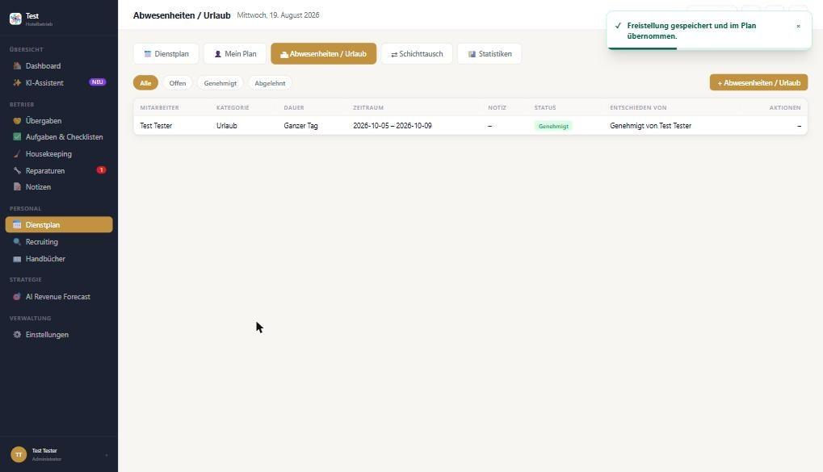
Fig. B15 – Vacation saved; ISO date format, no actions

2.7 Recruiting
Test case: job ad “Housekeeping-Mitarbeiter/in (Saison 2027)”, department Housekeeping, start from April 2027, benefits “directly on Lake Wolfsgruben, family team in its 3rd generation, accommodation available” → “Generate with AI” → save as draft.
Works: overview with modules, form (classic/quiz), live preview, AI text generated incl. thank-you message, languages DE/EN/IT selectable.
Bugs / requests:
- 2-H4: The AI invents benefits (“free meals”, “flexible working hours”, “development opportunities”) and drops the ones entered (lake location, accommodation). It sets the start to “immediately” instead of April 2027 and changes the title to “Hauswirtschaftsmitarbeiter/in”. This is a legal risk – the AI must only use facts that were entered.
- The location reads “test, Italien” (from the registration data) → see Module 1, hotel master data.
- “Save as draft” marks the image fields red and does not save – without a message. A draft should be possible without images.
- 2-H6: The banner shows a developer command (“docker compose exec … ai_recomendation:daily”).
- Staff (HR) is a separate list; the existing 2 users do not appear there → double maintenance. Please clarify how it relates to “Settings → Users”.
- 2-H7 (reported by Klaus): The quiz funnel (“Kurzes Quiz”) is not generated. It always loads the same hard-coded template from a craft/carpentry business (“Kunden mit Holzkunst begeistern”, “Das beste Werkzeug … Schutzkleidung”, “ohne Reisen durch ganz Deutschland”, “Muster GmbH”, “Max Mustermann”). Placeholders are not replaced ([Berufsbezeichnung], [Stadt], “XX € / Stunde”, “Bereich XY”, “Ab sofort”). Title, department, start date and benefits from the classic form are not carried over (title and department fields in the quiz editor are empty), and the quiz editor has no “Generate with AI” action. Expected: the funnel is generated from the job data and hotel master data, using only the facts entered (see 2-H4). Publishing the current template would show false information to applicants.
- Not tested: publishing, applications pipeline, campaigns, email templates.
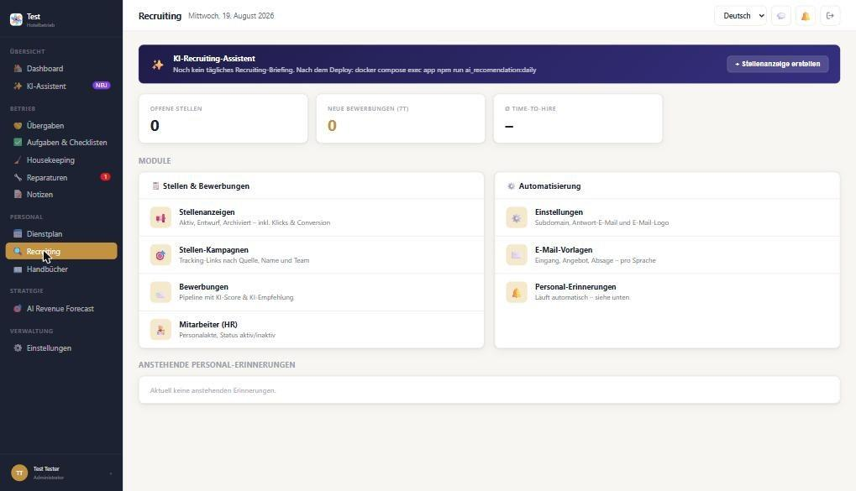
Fig. B16 – Recruiting start page with developer command in the banner
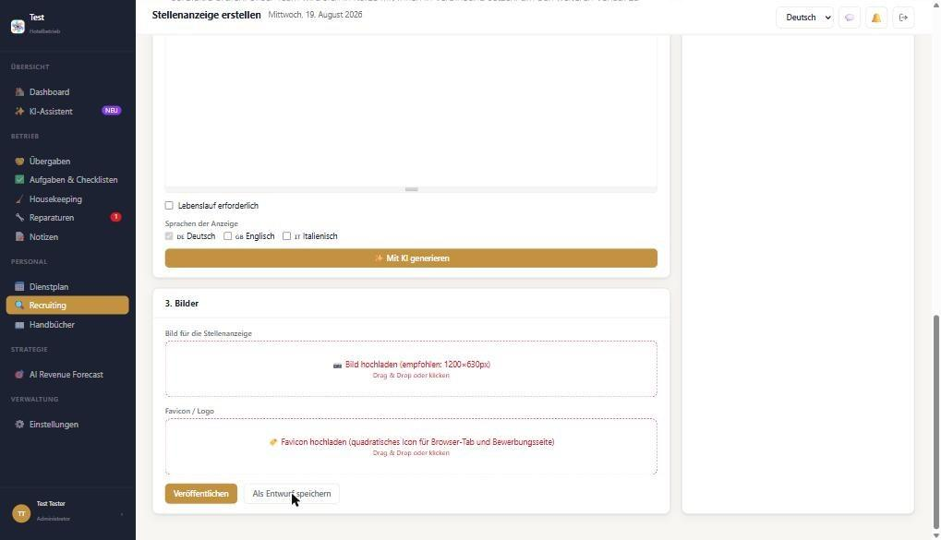
Fig. B17 – Saving the draft fails on mandatory images (no message)

2.8 Manuals
Works: filter by department, upload form with assignment, validation “Bitte eine Datei wählen.”
Open: the upload could not be tested – I cannot pass a file into the browser from this session. According to the notice, manuals use the knowledge base, which currently fails with “MCP_NOT_ACTIVE” (1-H5). Please test with a PDF yourself, e.g. indoor pool house rules.
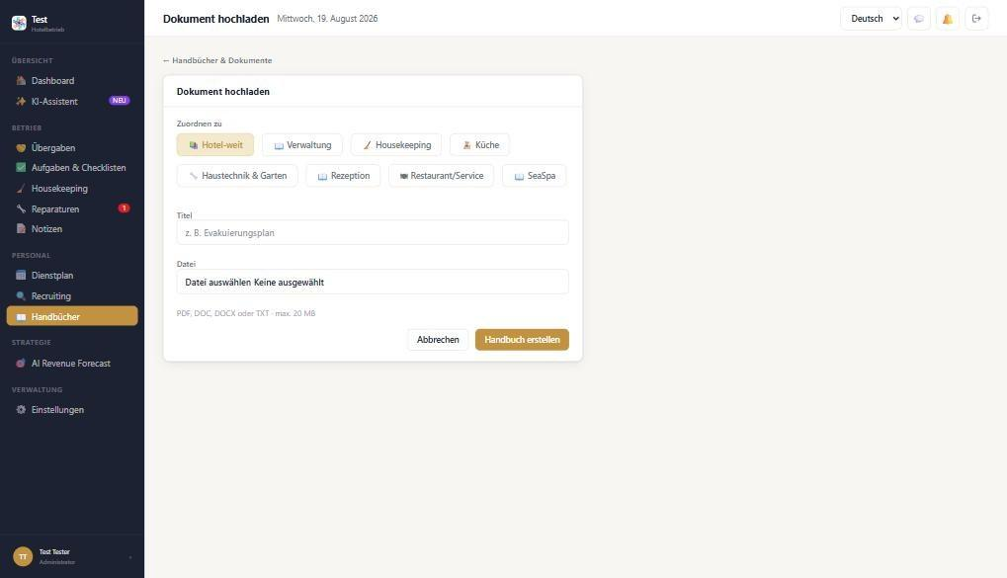
Fig. B18 – Manuals by department

2.9 AI revenue forecast
Still open according to the developer. The page shows only demo data (daily recommendations from 22 Aug, market position #1 of 12 hotels, €1.42 m). Until finished, please show a “demo data” label or hide the menu item so nobody sets prices based on it.
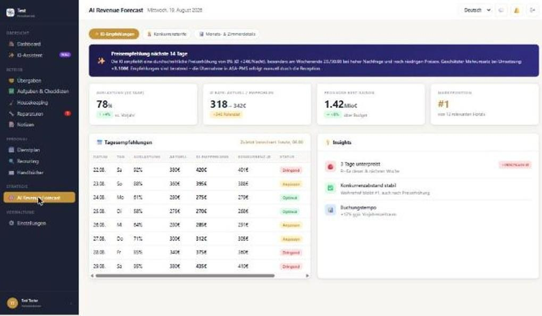
Fig. B19 – AI revenue forecast with demo values

3. Cross-cutting
- The header still shows a fixed “Mittwoch, 19. August 2026” (1-H6).
- Most forms show the translation notice, and the toasts “Wird in die anderen Sprachen übersetzt …” work.
- A complete test of housekeeping, shift planning and roles needs 3–4 test users (e.g. housekeeping, reception, maintenance, kitchen). Creating them depends on 1-H1/1-H2 (password/invitation).

4. Test data created in DEV (Module 2)
- Repair “Kneippbach-Pumpe verstopft (Sediment)” – in progress, with comment.
- Checklist template and checklist “Wochenkontrolle Hallenbad & Kneippbach” – completed (2/3).
- Task “Willkommenspaket Zimmer 45 vorbereiten” – done.
- Handover “Frühschicht → Spätschicht Rezeption” – open.
- Note “Stammgäste Fam. Huber – Zimmerwunsch” (reception).
- Shift Test Tester, Mon 21 Sep 2026, 09:00–17:00 (not yet published); vacation Test Tester 5–9 Oct 2026.
- Job ad not saved (draft fails, see 2-H4).

Part C – Limits of this test
What was not checked or only partially checked

Not testable with the current setup
- Only one administrator account: no check whether staff really only see their permitted modules and whether blocked pages are reachable via direct URL (security-relevant).
- No second user: chat receiving, notifications (bell), assignment to cleaners, housekeeper view, shift swap, AI shift suggestion.
- File uploads (attachments, manuals, job ad images) could not be passed from the test session.
- Submitting registration, creating users with a password, activating 2FA and password reset – to be done by Klaus.
- Desktop view only; the mobile view is still in progress according to the developer.

Only checked superficially
- Shift planning: shift templates, copy week, publish, export/print, “My plan”.
- Recruiting: applications pipeline, campaigns, email templates, settings, staff reminders.
- AI assistant: sub-assistants (handover, review, budget, recruiting, manuals, shift plan).
- AI revenue forecast: tabs “competitor rates” and “month/room details”.
- Search, filters, archive, edit and delete in most modules; Italian/English view outside of departments.
- The mockup comparison was done by sampling, not item by item.

Unconfirmed findings
The browser automation froze several times during the test. Two observations may therefore come from the test tool rather than the app and are marked “Unconfirmed” in the text: a delete click that did not respond (Part A, departments) and a first click on a checklist template that did not respond (Part B). Please also briefly confirm whether some points are intentional (e.g. rooms only visible after PMS import, team members assigned elsewhere).

Proposal for the next test round
- Create 3–4 test employees with different roles and departments (housekeeping, reception, maintenance & garden, kitchen).
- Then test: role and permission views incl. direct URLs, housekeeping assignment and status workflow, chat between two people, notifications, Italian UI from an Italian-speaking employee’s perspective.

